**Drop 3D Effect Tutorial v1.4**

**1. Demo.**

Check WebGL demo example:

<http://nubick.github.io/plugins/d3dewebgl/index.html>

or

Open "Demo" scene from "Assets/Plugins/Drop3DEffects/Demo" directory and try different animations and models.

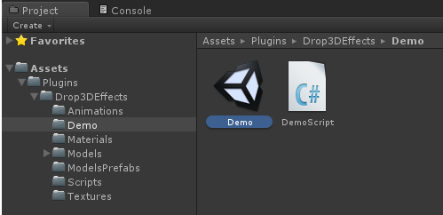

**2. Camera.**

Plugin uses separated camera to play animation, which is the first layer in game.

Get “AnimationCamera” prefab from “Assets/Plugins/Drop3DEffects” directory and move it into “Hierarchy”. All animations are tuned for this camera and should be placed as this camera children.

**3. Animations.**

You can find all animations in directory “Assets/Plugins/Drop3DEffects/Animations”.

Drag one of them and drop under “AnimationCamera”.

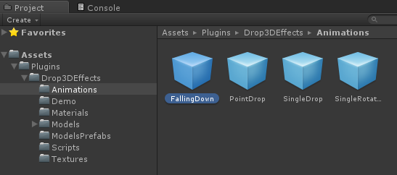 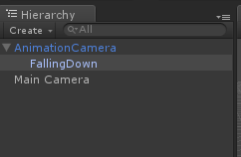

Directory “Assets/Plugins/Drop3DEffects/ModelsPrefabs” contains all prefabs of the models.

Select animation object from “Hierarchy” (“Animator3D” script) and set ObjectPrefab field by one of prefab model from directory:

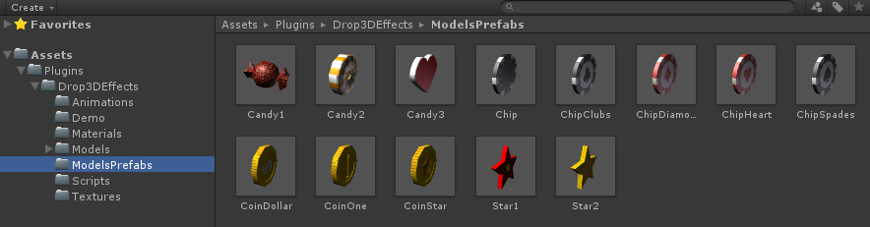

You can change other animation parameters:

“Name” – animation name. Used to run animation from code by name.

“Object Prefab” – set prefab of the model which will be animated.

“Count” – count of objects which will be in animation.

“Duration” – duration of animation.

“Start Speed” – animation running speed. Base value is 1 but you can make animation quicker or slower .

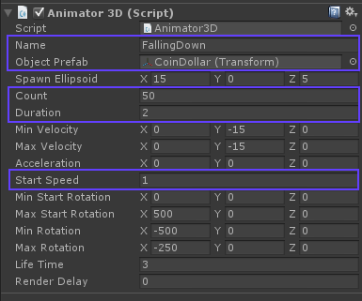

**4. Play animation.**

When you want to play animation from code just write:

Animator3D.Run(“PointDrop”);

Where “PointDrop” is value of animation “Name” property.

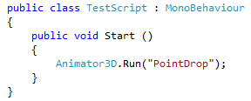

If you have reference to animation instance, you can play it using Run() method:

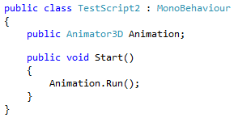

**5. Support.**

For any questions write to me: [nubick@gmail.com](mailto:nubick@gmail.com?subject=Drop%203D%20Effects%20v1.2)